Investment Committee Paper
Millbrook Solar & Storage – development budget and community fund
Liam McAllister · 22 May 2026 · IC-2026-05

1. Decision requested
- Approve a development budget of EUR 3.10 m up to planning consent (spent to date: EUR 1.88 m).
- Approve a community fund of EUR 120,000 per year, index-linked, for the operational life.
- Note the capex estimate of EUR 78.0 m and the planned EPC award to the preferred bidder in Q2 2027.

2. Investment case
Metric | Value
Total capex | EUR 78.0 m
P50 generation | 91.3 GWh/a
Power price assumption (years 1–15) | EUR 72/MWh (CfD-style strike price)
BESS revenue (year 1, conservative) | EUR 2.1 m
Project IRR (pre-tax, unlevered, 35 years) | 7.0 %
Equity IRR (70 % gearing) | 9.6 %

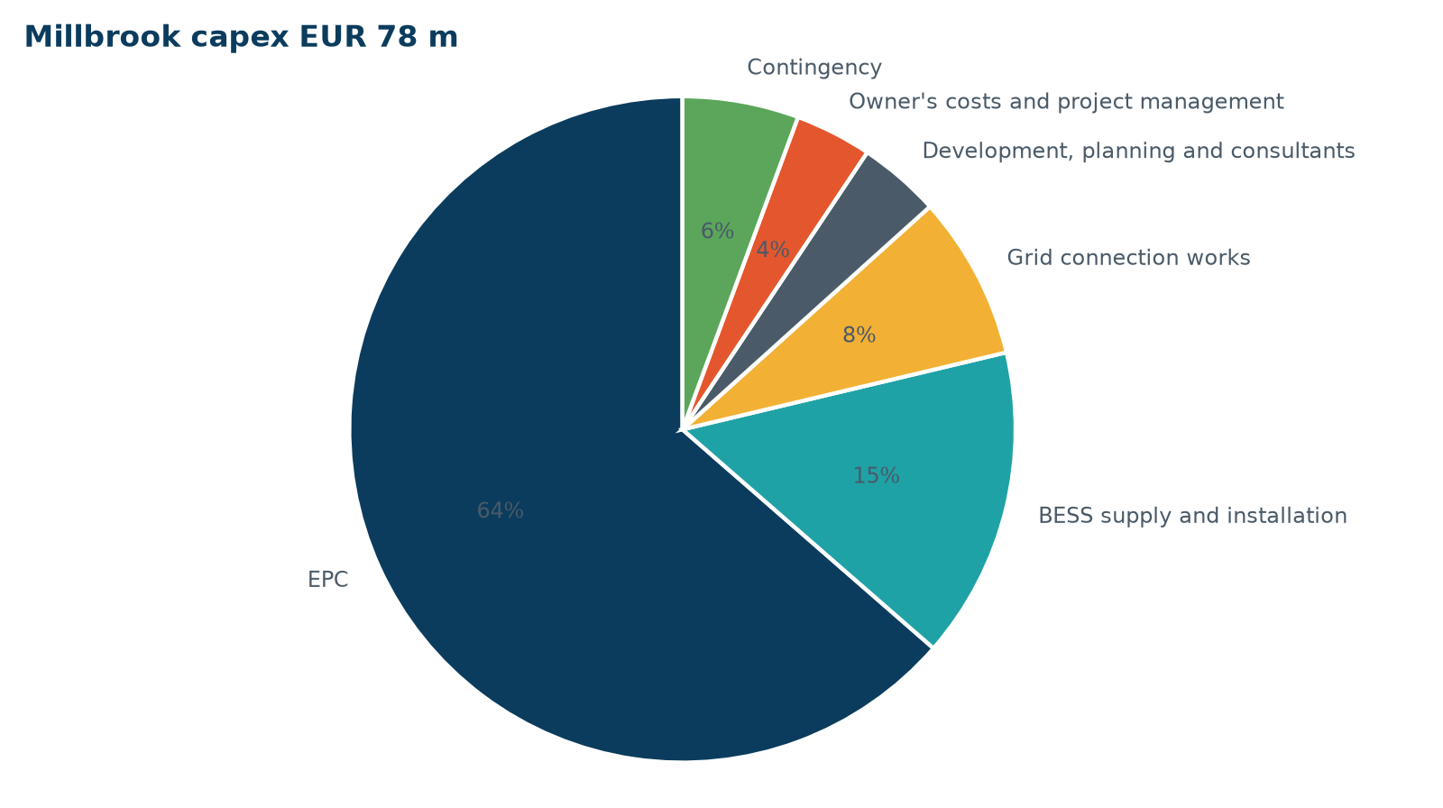
Capex breakdown

3. Why a community fund of this size
EUR 120,000 per year equals about EUR 1,400 per MWp, in line with the upper end of market practice for solar. It answers the most common question at consultation #1 ('what does the village get?') and costs 0.15 percentage points of project IRR.

4. Risks
Top risks are a refusal or deferral at committee (MB-RISK-001), construction traffic objections (MB-RISK-002) and the grid date (MB-RISK-004). See the risk register for mitigation.
Approved by the Investment Committee on 26 May 2026.

